Science-7 Name ___________________________ Date __________
Mr. Roach / Ms. Larson

Comparing & Contrasting: Plant vs. Animal Cells

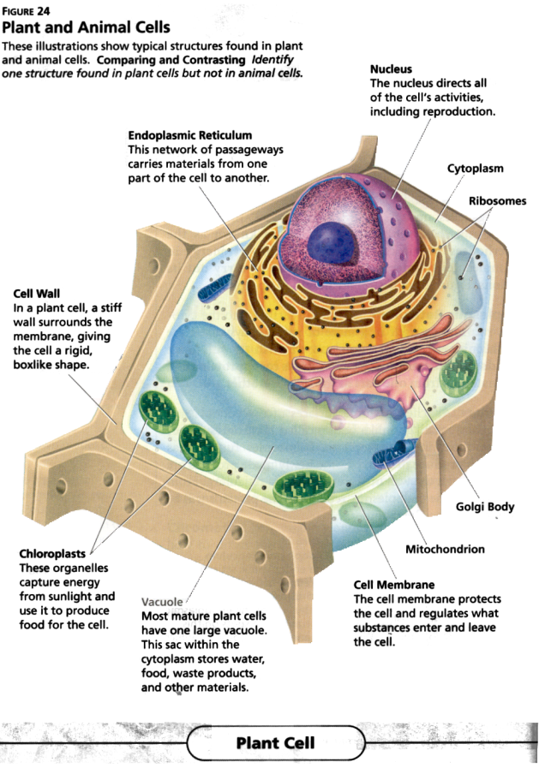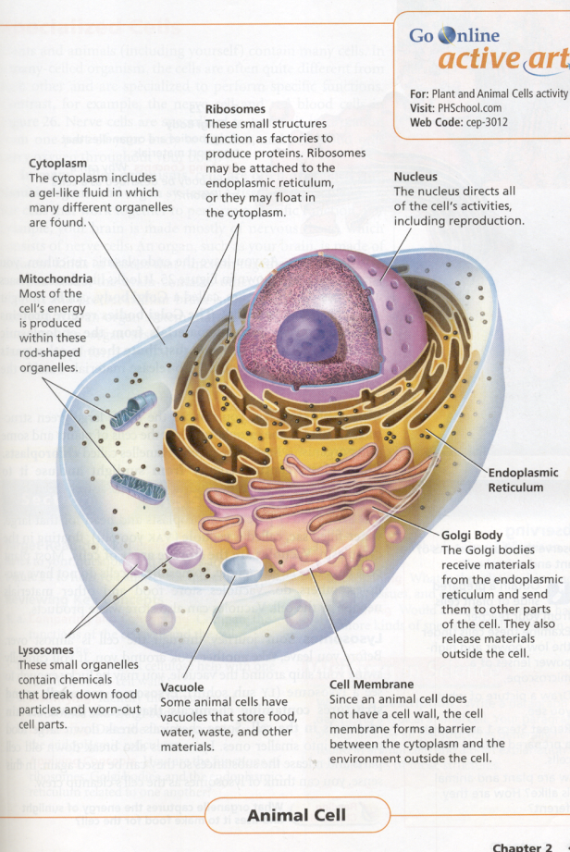

Use the diagrams above to list the structures that are the same in both cells, and the structures that are found in only one of the cells.

Structures Found Only  In Plant Cells | Structures Found Only  In Animal Cells | Structures Found  In Both Types of Cells

